**Developing a Flight Delay Prediction Model using Machine Learning.**

**Customer Journey**

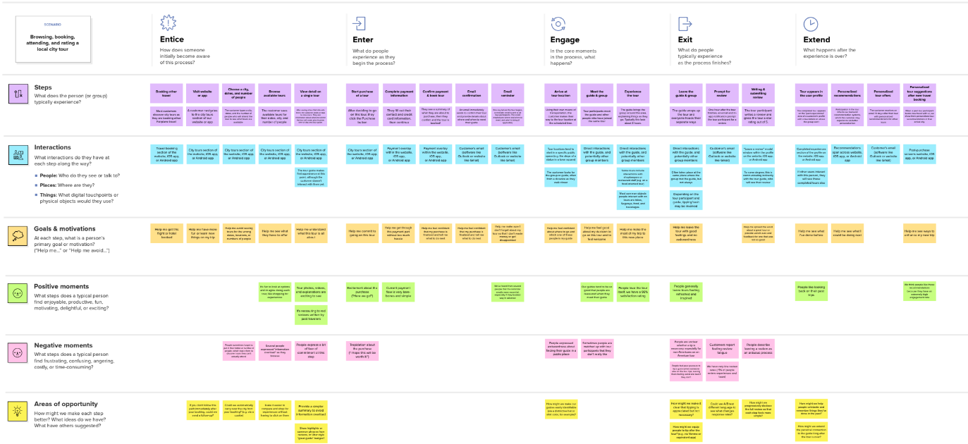

Since ﬂight delays cause economic consequences to passengers and airlines, recognizing them through prediction may improve marketing decisions. Due to that, several forecast models have been built over the last twenty years. These models have sought to understand how delays propagate through the network of ﬂights or airports, to predict root delay in the system or to comprehend the cancellation process. Beyond these three points of view for treating the ﬂight delay prediction problem, models could also diﬀer by their scope of application, data issues and methods